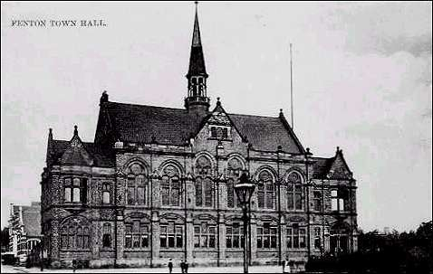

CREWE D
KEEP THE DREAM ALIVE
IN
GOTHIC REVIVAL
ENIGMATIC MASTERPIECE

Crewe D travelled to play Fenton B with all their original starting squad from the beginning of the season in October. Lukasz on 1; myself on 2; with George & Julian Bulbeck, respectively on 3 & 4.

There was a remote and very unlikely chance that we could still win the league. However, to do so meant winning our two remaining games; and an extremely unlikely series of other results, going our way. We entered this match knowing we could only influence that which is possible and then leave the rest to the fates!

As the evening light began to dim when we pulled up near Fenton’s new venue we were met by an impressive, Victorian edifice (no not Steve E before anyone says) which is now their home; or is it lair? As we mounted the steps to the imposing front door I half expected......................................
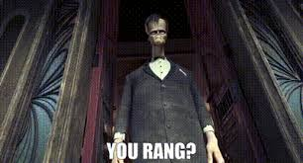

The building’s interior didn’t disappoint and we settled down in the spacious cafe and the games began in earnest; (which was very good of Mr Wilkinson as he was having an internal club game at the time).

As the evening light dimmed it became apparent that the lighting within the cafe was designed to be in keeping with the Gothic building and a slightly eerie glow, descended over the boards.
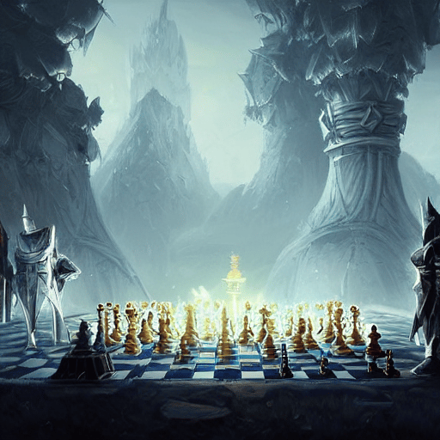
The silence was broken only by the occasional, muted chatter from Fenton’s club games and the infrequent, but less-muted spluttering of the Cappuccino machine on the cafe counter.

The games pushed on. As black on 2 I played Steve Emmerton and after a dozen moves I felt tired and could see a long, turgid evening ahead. I felt I would slowly slip into the Slough of Despond, and meet an inauspicious end, as the murky depths engulfed me.

Enough of that I thought!!! So, I sacked a Bishop for 2 pawns and an attack with my Queen and Knight which I knew shouldn’t go anywhere. In fact, on analysis afterwards Steve said to me that he knew the sack was not going to go anywhere! Guess what 5 moves later I’d won!!!!!!
Hoorah. Steve had the choice of 3 moves to get out of my attack and two really bad ones that would have caused him quite a bit of trouble. However, he managed to find an even worse one that gave him the choice of losing his Queen and/or being mated.
Maybe the sack wasn’t so bad as I was now able to relax with some chocolate and a coffee whilst the team played on. I had an extra helping of smugness with my coffee making it taste even better.

The other games were destined for the wee small hours. All were very evenly poised and at one point I could see us losing all 3. In a very sarcastically surprising sort of way George had gotten himself into time trouble..........................................again! But remember George you said you play better when under time pressure!!!!!
In fact, he was in so much time trouble he even let me record for him in my ancient, Sumerian, cuneiform script.
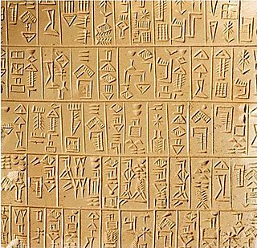
Despite being well in the game the time pressure was so intense George began to crumble. In fact, at one point Steve E asked me why I was recording when George had 8 minutes on his clock: Steve; I said” Those are seconds”. Unfortunately, the end came swiftly and George’s opponent who is relatively new to league chess chalked up a well deserved win and it was 1-1.

Meanwhile on 1 Lukasz was having a battle royale with Chris Hankey, who is significantly higher-rated. Eventually, Lukasz admitted, he ran out of attacking ideas and the game petered out to a well earned draw; keeping the match very much on tenterhooks.

Julian on 4 had a very complicated position and was a piece down but had two, connected passed pawns on the 6th and 7th ranks. Both players looked like they were going to win at different stages but after an exchange of some of the minor pieces the past pawns gave Julian the advantage. He wasn’t able to promote them but they drew his opponent’s King to the wrong side of the board and resignation swiftly followed.

A great win for the D team which was never in the bag until Julian did his impression of a fat lady singing!!!!

Next up is Stafford away. The dream is alive although it could have been a Gothic Nightmare!
